**Experiment No:- 7**

**Aim:** Develop an application that uses GUI components.

**1. Code for Activity_main.xml**

<?xml version="1.0" encoding="utf-8"?>

<LinearLayout xmlns:android="http://schemas.android.com/apk/res/android"

android:orientation="vertical"

android:layout_width="match_parent"

android:layout_height="match_parent">

<TextView

android:id="@+id/textView"

android:layout_width="match_parent"

android:layout_height="wrap_content"

android:layout_margin="30dp"

android:gravity="center"

android:text="Hello World!"

android:textSize="25sp"

android:textStyle="bold" />

<Button

android:id="@+id/button1"

android:layout_width="match_parent"

android:layout_height="wrap_content"

android:layout_margin="20dp"

android:gravity="center"

android:text="Change font size"

android:textSize="25sp" />

<Button

android:id="@+id/button2"

android:layout_width="match_parent"

android:layout_height="wrap_content"

android:layout_margin="20dp"

android:gravity="center"

android:text="Change color"

android:textSize="25sp" />

</LinearLayout>

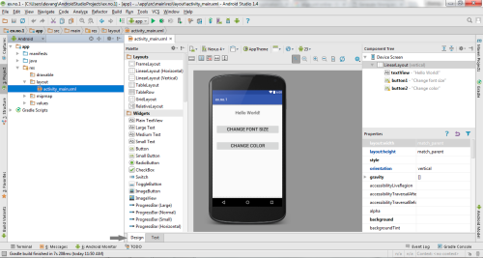

**2. Code for MainActivity.java:**

package com.example.exno1;

import android.graphics.Color;

import android.support.v7.app.AppCompatActivity;

import android.os.Bundle;

import android.view.View;

import android.widget.Button;

import android.widget.TextView;

public class MainActivity extends AppCompatActivity

{

int ch=1;

float font=30;

@Override

protected void onCreate(Bundle savedInstanceState)

{

super.onCreate(savedInstanceState);

setContentView(R.layout.activity_main);

final TextView t= (TextView) findViewById(R.id.textView);

Button b1= (Button) findViewById(R.id.button1);

b1.setOnClickListener(new View.OnClickListener() {

@Override

public void onClick(View v) {

t.setTextSize(font);

font = font + 5;

if (font == 50)

font = 30;

}

});

Button b2= (Button) findViewById(R.id.button2);

b2.setOnClickListener(new View.OnClickListener() {

@Override

public void onClick(View v) {

switch (ch) {

case 1:

t.setTextColor(Color.RED);

break;

case 2:

t.setTextColor(Color.GREEN);

break;

case 3:

t.setTextColor(Color.BLUE);

break;

case 4:

t.setTextColor(Color.CYAN);

break;

case 5:

t.setTextColor(Color.YELLOW);

break;

case 6:

t.setTextColor(Color.MAGENTA);

break;

}

ch++;

if (ch == 7)

ch = 1;

}

});

}

}

**OUTPUT:-**

